**Project Deliverable 2 – Documentation and Coding**

**Faculty Name:** Information Technology

**Module Code:** ITECA3-B12

**Module Name:** Web Development and e-Commerce

**Content Writer:** Sandile Dlamini

**Copy Editor:** Mr Kyle Keens

**Submission Date:** Block 2 Week 4

|  |  |
| --- | --- |
| **Student Name** | Alec Wasserfall |
| **Student Number** | dv.2022.n3n0t1 |
| **Project Title** | ITECA3-B12_Individual Assignment_Tyger Valley_Dv.2022.n3n0t1 |
| **Submission Date** | 10 June 2024 |

Important  
Link to the file I used to create the website  
<https://github.com/Crimie-Chaos/ITECA3-B12_Individual-Assignment_Tyger-Valley_dv.2022.n3n0t1.git>

**Table of Contents**

2.1 Introduction 4

2.2 Prototyping 5

Front End 5

Back End 6

2.3 Designing 7

Class Responsibility Collaborator (CRC) cards 7

Enhanced Entity Relationship Diagram (EERD) 8

Context Diagram 9

Data Flow Diagram (DFD) 9

Use Case Diagram 10

2.4 Coding 11

Website Front End 11

Sample HTML Code 13

Sample JavaScript Code 14

Sample CSS Code 15

2.5 Conclusion 16

Key Features: 16

2.6 Sign-off 17

# Introduction

Welcome to PNA - Your Ultimate Destination for Stationery, Art & Craft Supplies, and More!

At PNA, we pride ourselves on being South Africa's favorite retailer for a comprehensive range of high-quality products. Whether you're a student, professional, artist, or simply someone who enjoys creative hobbies, PNA is your go-to source for all your needs.

Established in 1992, PNA has grown into a reputable and successful franchise with over 100 independently owned stores nationwide. Our commitment to quality, affordability, and excellent customer service has made us a trusted name in the retail industry.

Our extensive product range includes stationery, art and craft materials, books, and educational supplies, ensuring that we cater to the needs of everyone in the family. We aim to equip you for success, inspire creativity, and help you discover more than you ever imagined.

At PNA, we believe in promoting family values, fostering committed and satisfied employees, and maintaining integrity in all our dealings. Our attractive store layouts and effective product branding make shopping a delightful experience.

Explore our website to learn more about our products. Join the PNA community and experience the best in retail.

Thank you for choosing PNA - Inspiring creativity, success, and discovery every day.

# Prototyping

## Front End

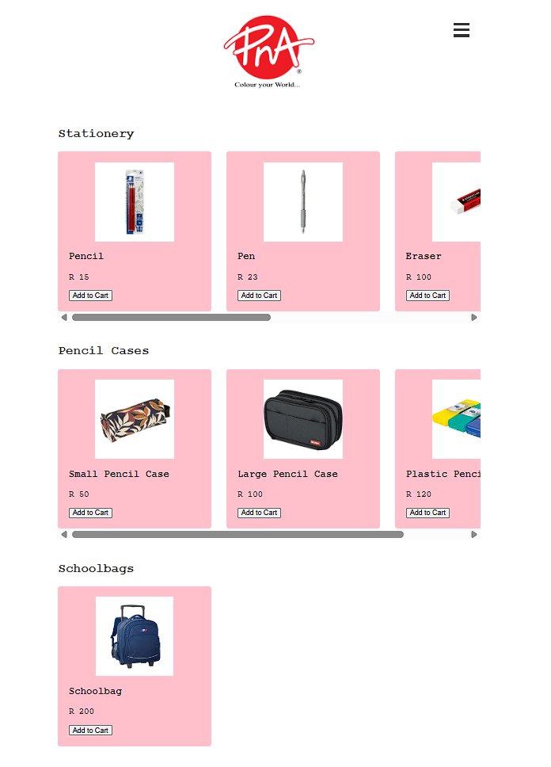

## Back End

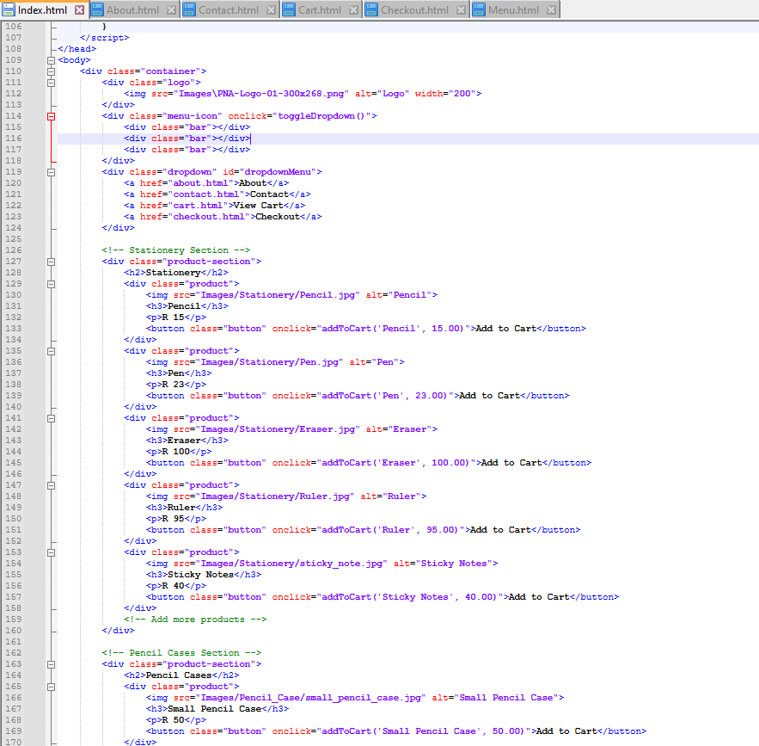

# Designing

## Class Responsibility Collaborator (CRC) cards

|  |  |
| --- | --- |
| **Class**: Customer | |
| **Responsibilities** | **Collaborators** |
| Browse products  Add product to cart  View cart  Checkout | Website |

|  |  |
| --- | --- |
| **Class**: Website | |
| **Responsibilities** | **Collaborators** |
| Add items to cart  Display cart to customer  checkout | Customer |

## Enhanced Entity Relationship Diagram (EERD)

## Context Diagram

## Data Flow Diagram (DFD)

## Use Case Diagram

# Coding

## Website Front End

## Sample HTML Code

## Sample JavaScript Code

## Sample CSS Code

# Conclusion

The PNA website offers a comprehensive and user-friendly platform for customers to explore and purchase a wide range of products, including stationery, pencil cases, and schoolbags. Designed with a clear and modern interface, the website ensures that users can easily navigate through different product categories and find the items they need.

### Key Features:

1. **Product Listings:**
   * Detailed product descriptions and high-quality images help customers make informed purchasing decisions.
   * Users can view a variety of products across multiple categories, ensuring they have access to all their school and office supply needs.
2. **User-Friendly Navigation:**
   * The intuitive layout and menu system allow users to easily find information about the company, contact details, and their shopping cart.
3. **Shopping Cart Functionality:**
   * The website features a robust shopping cart system where users can add, view, and remove items.
   * Integration with local storage ensures that the cart contents are preserved even when the user navigates away from the page.
4. **Responsive Design:**
   * The website is designed to be responsive, ensuring a seamless experience across various devices, including desktops, tablets, and smartphones.

# Sign-off

|  |  |  |  |
| --- | --- | --- | --- |
| PNA |  |  | Alec |
| [Name], Project Client  Date: 2024-06-14 |  |  | [Name], Project Manager |